

~~ **Building a Resilient Community with** ~~

**What is Meshtastic?**



Meshtastic is an open-source communication platform that allows users to send and receive text messages over long distances without relying on the internet, cellular service, or the power grid. It operates on low-power, long-range radio technology (*LoRa*), making it an ideal solution for off-grid and emergency communication. You can find more information on the official Meshtastic website and in this introductory video (*see back for QR codes*):

* Meshtastic Introduction:<https://meshtastic.org/docs/introduction/>
* Introduction to Meshtastic Video:<https://www.youtube.com/watch?v=s6Z6Z0Iizgg>

**The Need for a Resilient Communication Network**



As the world becomes more connected, we are increasingly vulnerable to disruptions in our communication infrastructure. Natural disasters, power outages, or even simple network congestion can leave us without the ability to connect with loved ones, access critical information, or coordinate assistance in an emergency. Meshtastic provides a robust and independent communication network that can function when all else fails.

*By establishing a local Meshtastic network, we can create a resilient communication backbone for our community, ensuring that we can stay connected during times of crisis.*

**How Meshtastic Works**



Meshtastic devices create a "*mesh network*." Each device, or "*node*," in the network acts as a repeater, extending the range of the network by relaying messages from other nodes. This creates a decentralized and self-healing network that becomes stronger and more reliable as more users join.

The key features of Meshtastic include:

* Long-Range Communication**:** Capable of sending messages over many miles, depending on the terrain and antenna used.
* Low Power Consumption: Devices can run for extended periods on small batteries or solar power.
* Encrypted Communication: All messages on the network are encrypted, ensuring privacy and security.
* GPS and Location Sharing: Optional GPS capabilities allow users to share their location with others on the network.
* Open-Source and Community-Driven: The platform is developed and maintained by a global community of volunteers, ensuring it remains free and accessible to all.  
  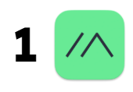

**Building a Community-Owned Network**



The strength of a Meshtastic network lies in its community. By deploying a network of nodes throughout our community, we can create a powerful and reliable communication tool for everyone. Placing a few relay nodes in strategic, high-elevation locations can significantly expand coverage and encourage broader adoption. *I would ideally like to utilize a fiberglass antenna for a node on/around the [redacted].*

**Getting Involved**



We are looking to start building a local Meshtastic network and are looking for community members who are interested in participating or assisting monetarily. Whether you are a tech enthusiast, a community leader, or simply someone who wants to be better prepared for emergencies, there are many ways you can get involved:

* Set up your own Meshtastic node: The hardware is affordable and easy to set up.
* Help identify ideal locations for relay nodes: Help us jumpstart the network by identifying high-elevation locations for relay nodes.
* Spread the word: Share this information with your friends, family, and neighbors.

**Our Current Outlook/Plan**

The current plan is to purchase a pre-built solar relay from SeeedStudio, as it supports our current limitations as far as tools and the time constraint of this project (*may add fiberglass antenna*).

Specific hardware for this project includes:

* **SenseCap Solar Node P1:** <https://www.seeedstudio.com/SenseCAP-Solar-Node-P1-for-Meshtastic-LoRa-p-6425.html>

***Note****: Solar nodes will probably need to be placed in an accessible area to facilitate maintenance (like replacing batteries after a while or any major software updates).*

* *By working together, we can build a more resilient and connected community!*

**QR Codes: Join the Discussion!**

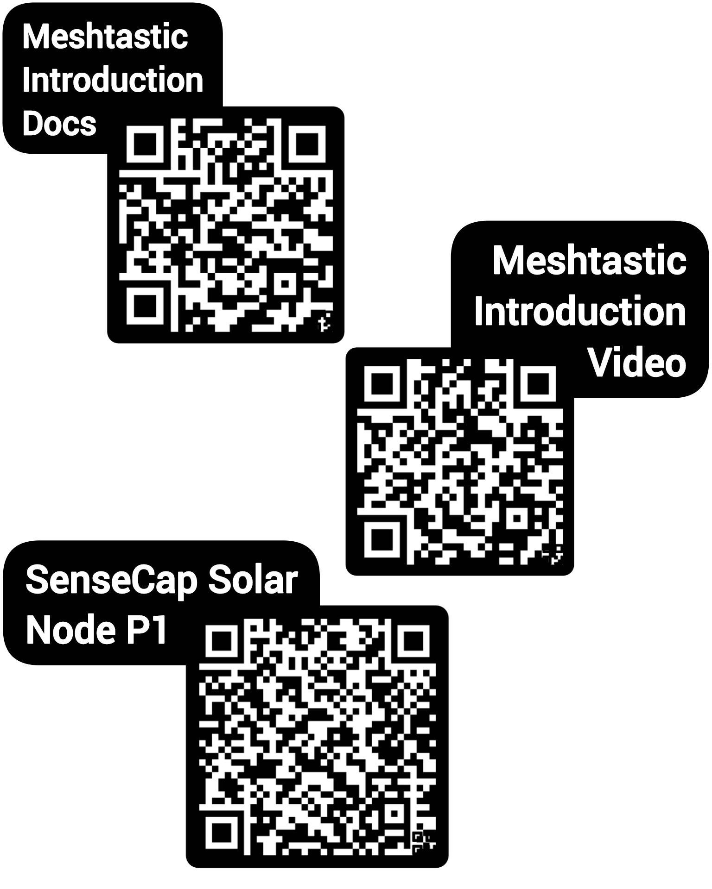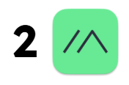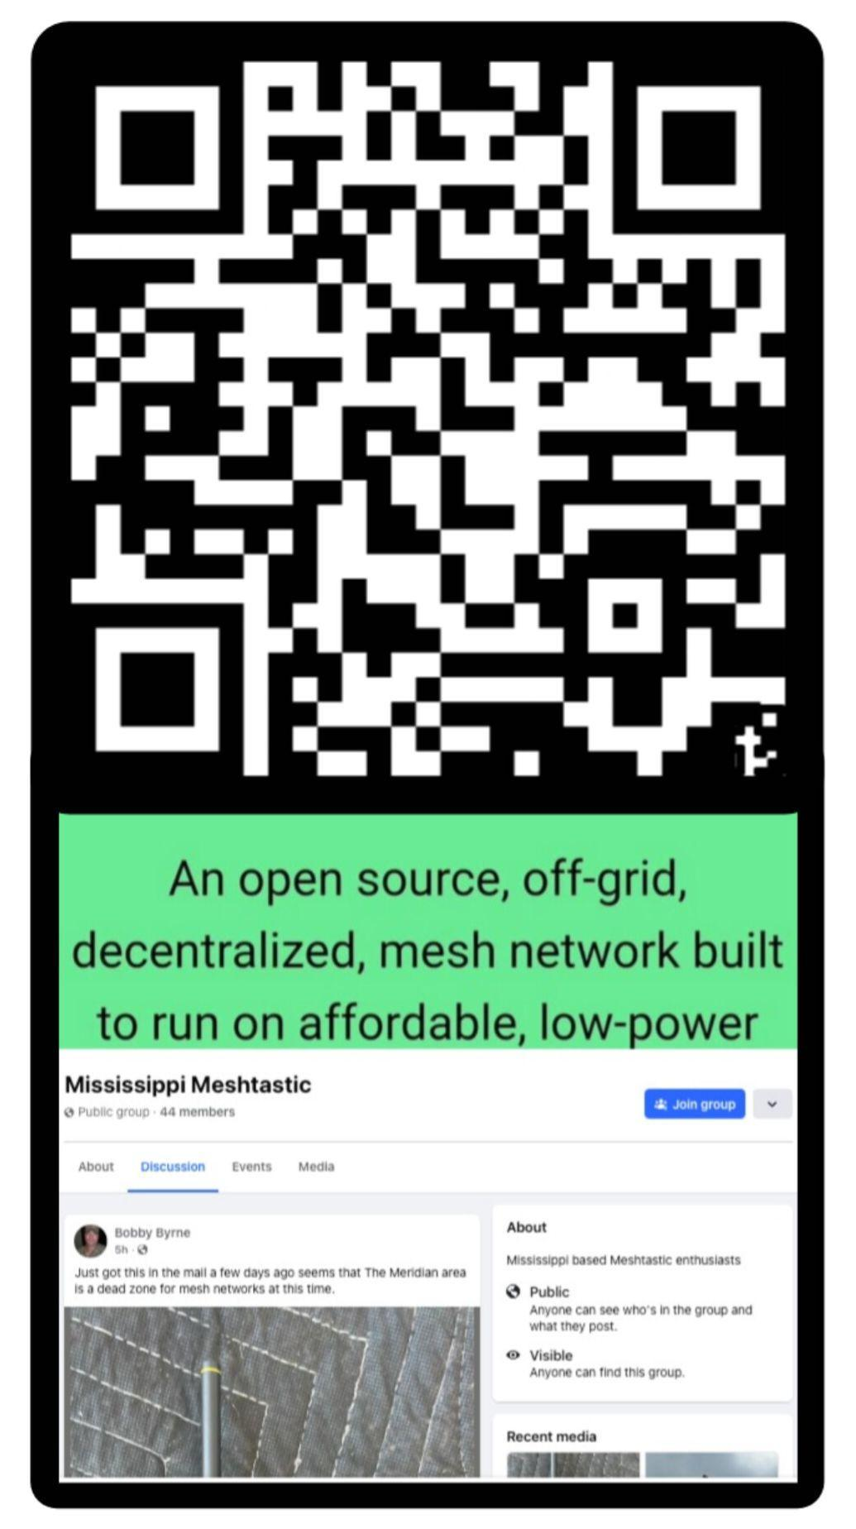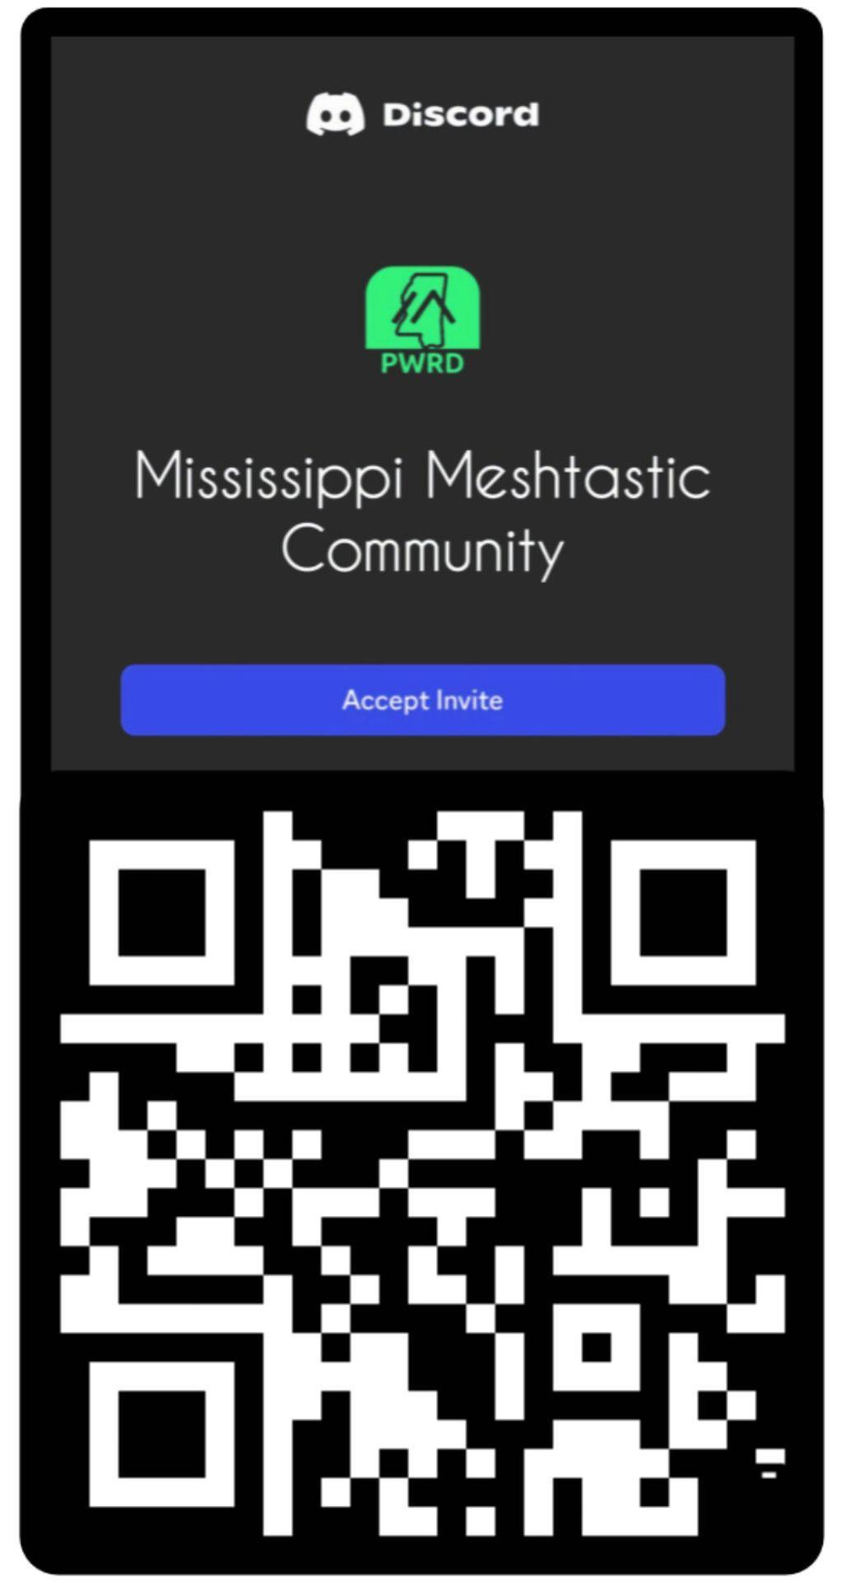 **Facebook: Discord:**